MY CV

This is my CV through Mobile Applications make in Android Studio

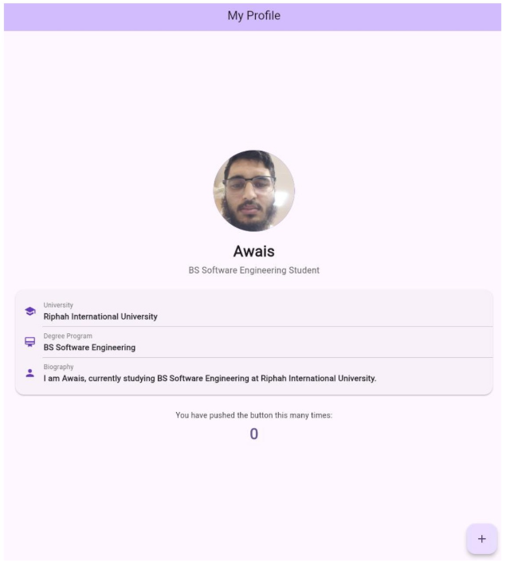

import 'package:flutter/material.dart';
void main() {
runApp(const MyApp());
}
class MyApp extends StatelessWidget {
const MyApp({super.key});
@override
Widget build(BuildContext context) {
return MaterialApp(
debugShowCheckedModeBanner: false,
title: 'Profile App',
theme: ThemeData(
useMaterial3: true,
colorScheme: ColorScheme.fromSeed(seedColor: Colors.deepPurple),
),
home: const MyHomePage(title: 'My Profile'),
);
}
}
class MyHomePage extends StatefulWidget {
const MyHomePage({super.key, required this.title});
final String title;
@override
State<MyHomePage> createState() => _MyHomePageState();
}
class _MyHomePageState extends State<MyHomePage> {
int _counter = 0;
void _incrementCounter() {
setState(() {
_counter++;
});
}
Widget _buildDetailRow(IconData icon, String title, String value) {
return Padding(
padding: const EdgeInsets.symmetric(vertical: 8.0, horizontal: 16.0),
child: Row(
children: [
Icon(icon, color: Colors.deepPurple, size: 22),
const SizedBox(width: 14),
Expanded(
child: Column(
crossAxisAlignment: CrossAxisAlignment.start,
children: [
Text(
title,
style: TextStyle(
fontSize: 12,
color: Colors.grey.shade600,
fontWeight: FontWeight.w500,
),
),
const SizedBox(height: 2),
Text(
value,
style: const TextStyle(
fontSize: 15,
fontWeight: FontWeight.w600,
),
),
],
),
),
],
),
);
}
@override
Widget build(BuildContext context) {
return Scaffold(
appBar: AppBar(
centerTitle: true,
backgroundColor: Theme.of(context).colorScheme.inversePrimary,
title: Text(widget.title),
),
body: Center(
child: SingleChildScrollView(
padding: const EdgeInsets.all(20),
child: Column(
mainAxisAlignment: MainAxisAlignment.center,
children: <Widget>[
// Profile Image
const CircleAvatar(
radius: 75,
backgroundColor: Colors.deepPurpleAccent,
backgroundImage: AssetImage('Resources/Images/profile.jpeg'),
),
const SizedBox(height: 16),
// Name
const Text(
'Awais',
style: TextStyle(
fontSize: 28,
fontWeight: FontWeight.bold,
),
),
const SizedBox(height: 4),
// Subtitle
Text(
'BS Software Engineering Student',
style: TextStyle(
fontSize: 16,
color: Colors.grey.shade700,
fontWeight: FontWeight.w500,
),
),
const SizedBox(height: 20),
// Biography Details Card
Card(
elevation: 2,
shape: RoundedRectangleBorder(
borderRadius: BorderRadius.circular(16),
),
child: Padding(
padding: const EdgeInsets.symmetric(vertical: 12.0),
child: Column(
children: [
_buildDetailRow(
Icons.school,
'University',
'Riphah International University',
),
const Divider(height: 1, indent: 50),
_buildDetailRow(
Icons.card_membership,
'Degree Program',
'BS Software Engineering',
),
const Divider(height: 1, indent: 50),
_buildDetailRow(
Icons.person,
'Biography',
'I am Awais, currently studying BS Software Engineering at Riphah International
University.',
),
],
),
),
),
const SizedBox(height: 24),
// Counter Display
const Text(
'You have pushed the button this many times:',
style: TextStyle(fontSize: 14),
),
const SizedBox(height: 6),
Text(
'$_counter',
style: Theme.of(context).textTheme.headlineMedium?.copyWith(
fontWeight: FontWeight.bold,
color: Theme.of(context).colorScheme.primary,
),
),
],
),
),
),
floatingActionButton: FloatingActionButton(
onPressed: _incrementCounter,
tooltip: 'Increment',
child: const Icon(Icons.add),
),
);
}
}

